|  |  |
| --- | --- |
| |  | | --- | |  | |

CABS Refurbishment

[**On Site Services**](https://www.elevationmaintenance.co.uk/services/on-site-spraying-services)

* [Cladding Coatings](https://www.elevationmaintenance.co.uk/services/on-site-spraying-services/cladding-coatings)
* [Roof Coating Systems](https://www.elevationmaintenance.co.uk/services/on-site-spraying-services/liquid-roof)
* Cut Edge Corrosion Treatments
* Rooflight Refurbishment
* Gutter Relining
* Industrial Roller Shutters & Doors
* Shop fronts, windows and [Curtain Walling](https://www.elevationmaintenance.co.uk/services/on-site-spraying-services/curtain-walling)
* [Giromax](https://www.elevationmaintenance.co.uk/services/on-site-spraying-services/giromax)

Shop fronts, windows and [Curtain Walling](https://www.elevationmaintenance.co.uk/services/on-site-spraying-services/curtain-walling)

CABS offer a range of solutions for the onsite re-spraying of aluminium framework to shopfronts, windows, and curtain walling. Working closely with construction companies, private landlords, major retail outlets and high street chains, our spraying operatives will achieve a high quality finish as close as can be achieved to a factory applied powder coated finish.

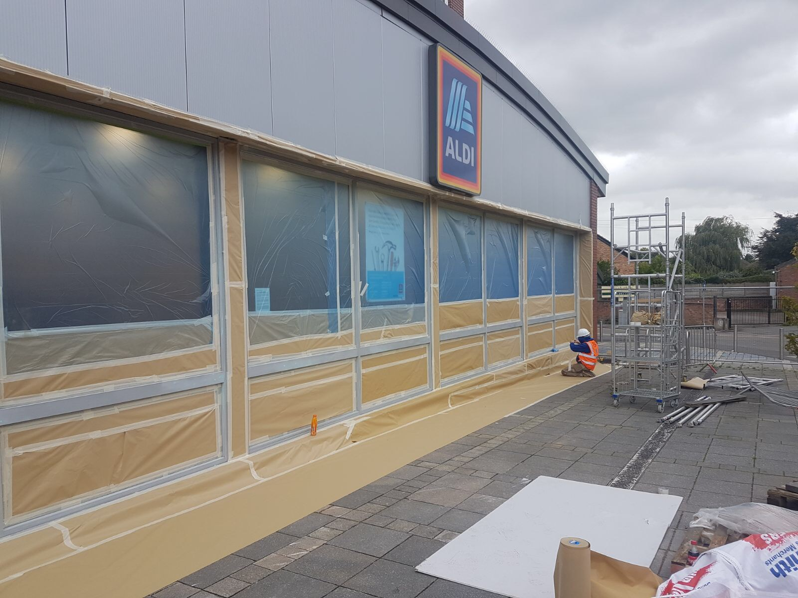

Industrial Roller Shutters & Doors

CABS specialise in the paint spraying of roller shutter, delivery and fire doors.

Using a range of application techniques including HVLP spraying and adapted roller methods CABS apply a range of coatings forming an incredibly strong bond, proving long-lasting protection.

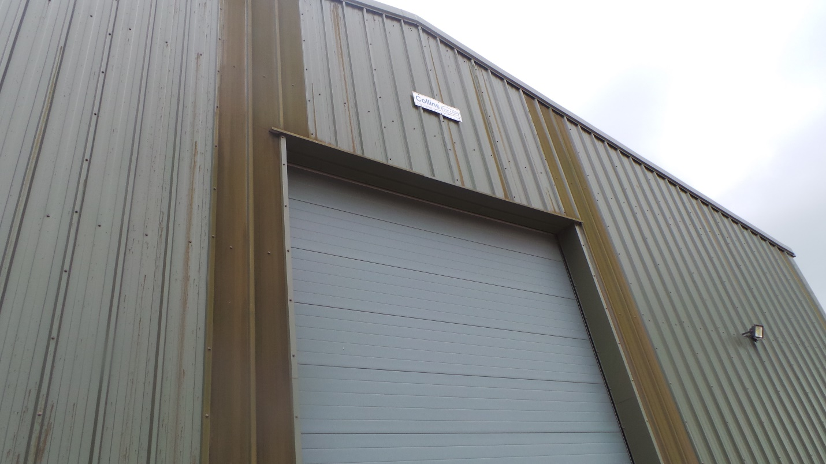

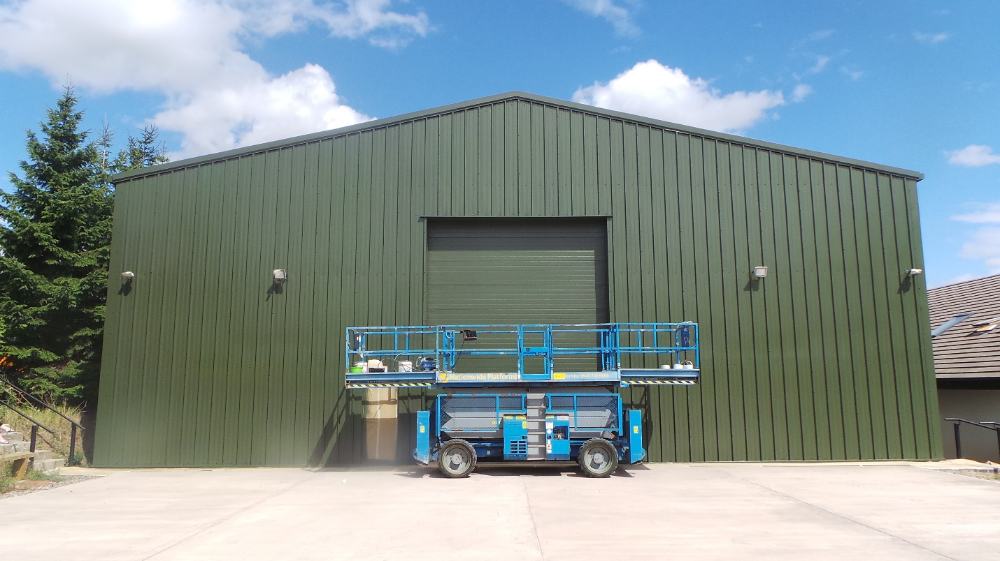

**Rooflight Refurbishment**

At CABS we offer a simple and cost effective for aged and weathered rooflights. As approved Giromax applicators our operatives specialise in the application of GIROSIL® Giroglaze.

This high performance solution delivers a tough durable finish for the recoat and sealing of existing rooflights that cures to provide a clear and tough membrane protecting against moisture and erosion.

​

* It is UV resistant and accommodates rooflight movement
* Primer-less adhesion to cleaned GRP surfaces
* Fast application without disruption to internal activities

[Giromax](https://www.elevationmaintenance.co.uk/services/on-site-spraying-services/giromax)

CABS are approved applicators of some of the marketing leading coating systems developed by Giromax, offering solutions for the repair and refurbishment of cladding, rooflights and gutter linings.

### DELCOTE HPG

DELCOTE HPG is a specialist membrane, with breathable properties suitable for application as a protective coating for a range of weather conditions or to completely coat the gutter surface on a property. It’s flexibility is one of it’s best qualities as it allows the product to withstand a selection of normal surface movements and is completely unaffected by UV.

### GIROCOTE

GIROCOTE is a mid-sheen, low odour coating that is completely emissions compliant. It is specifically designed to Polyester coated steel, allowing it to provide aesthetically pleasing and increased protection for the refurbishment and repair of profiled metal wall cladding panels.

### Seamsil Silicone Systems

Seamsil is a unique, highly flexible silicone remedial product developed to solve the [Cut Edge Corrosion](https://www.cjcoatings.co.uk/services/on-site-repair-and-replacement/cut-edge-corrosion-treatments) on steel cladding sheets. Seamsil has recently been recognised as the most versatile and effective treatment that completely encapsulates exposed metal where it may be subjected to aggressive moisture conditions.

Cladding Coatings

Coatings and Blasting Service can provide a specialist coating for PVC, PVF2, Plastasol and Steel surfaces. Reducing maintenance to the exterior of buildings which use the above panels.

As time progresses so does the degradation of original factory coatings. Increasing the costly need for maintenance and repairs. However, Coatings and Blasting Services are an approved contractor for the use of SteelSeal®. A product specifically designed for “making buildings beautiful again”.

It’s benefits include:

• Excellent weather durability.  
• Very long life expectancy reducing repainting costs.  
• Enhancing the buildings commercial value.  
• More cost effective and less disruption than re-cladding

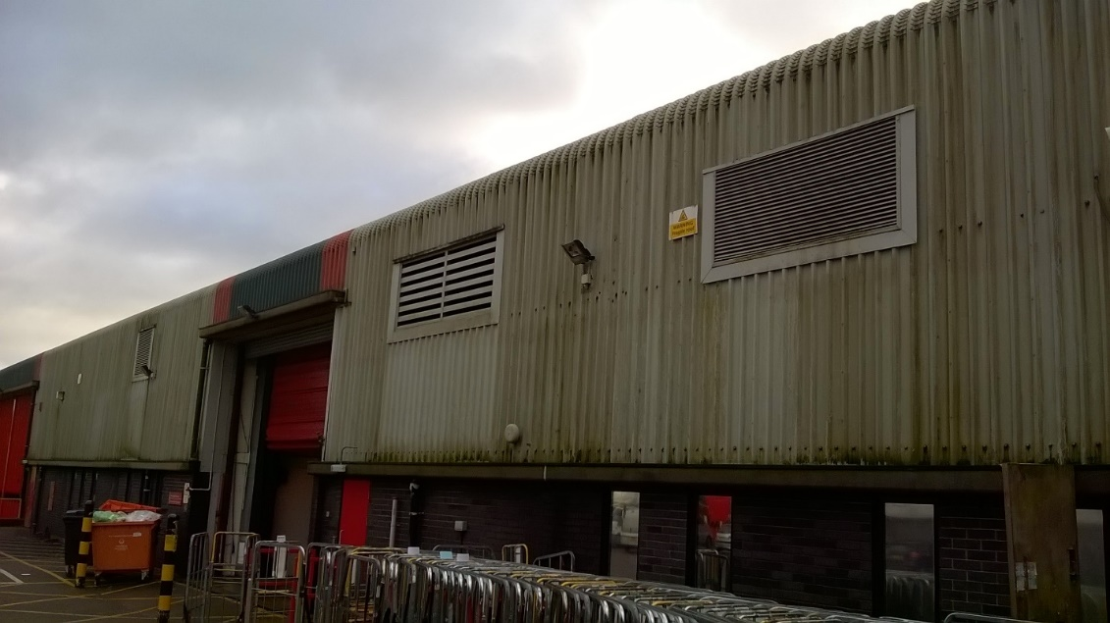

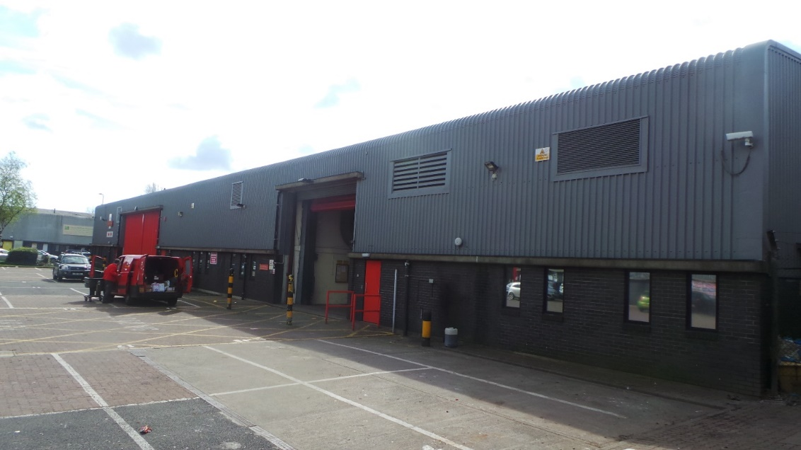

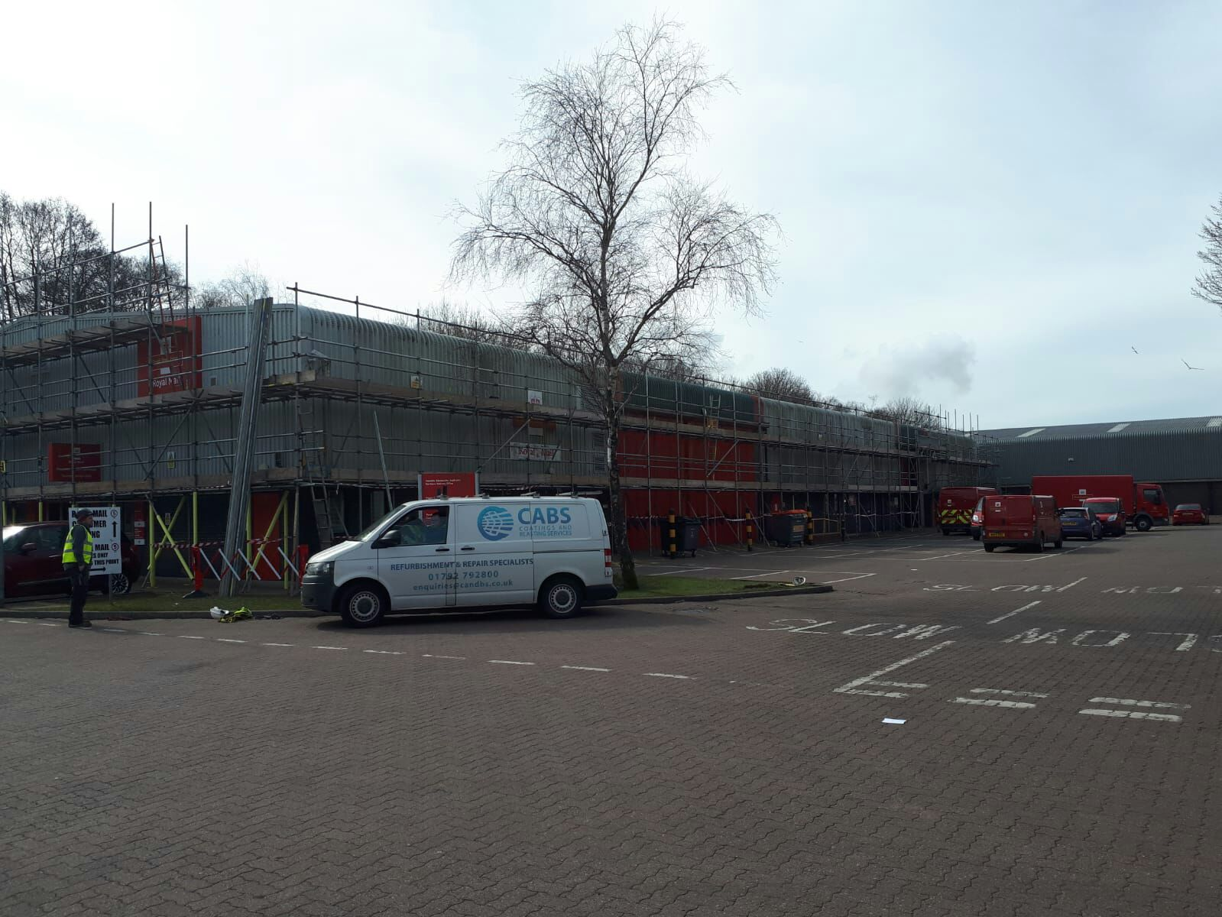

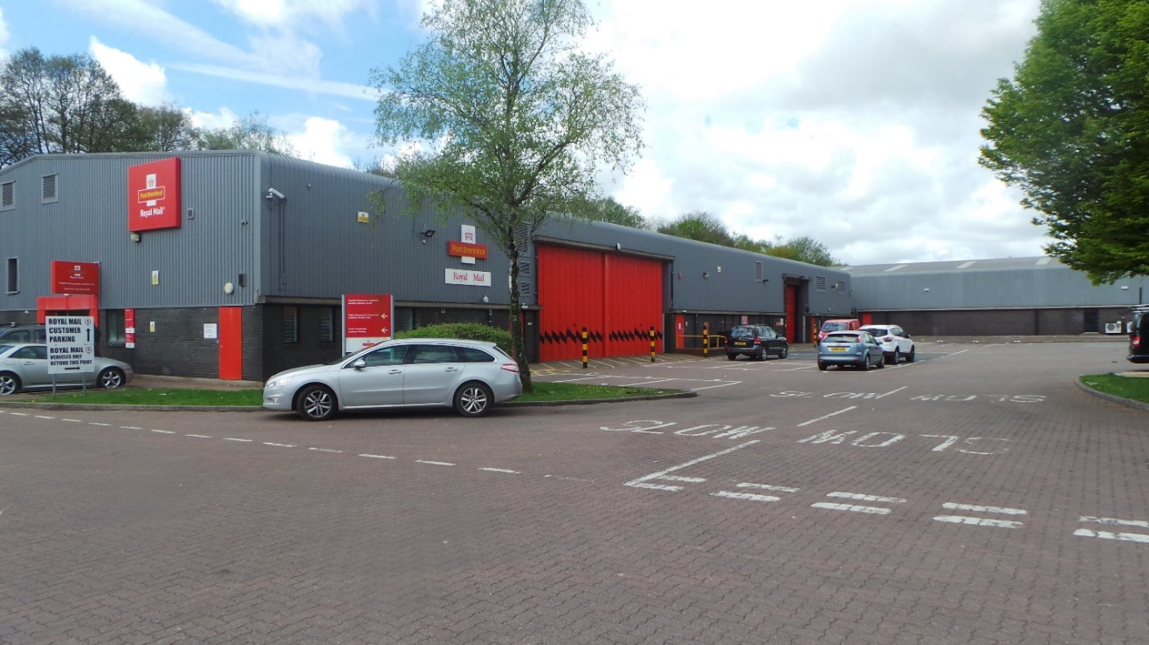

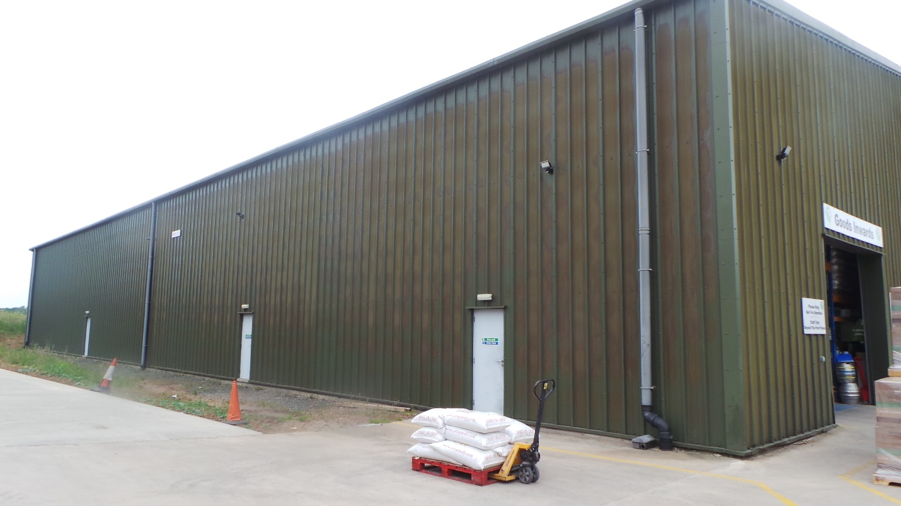

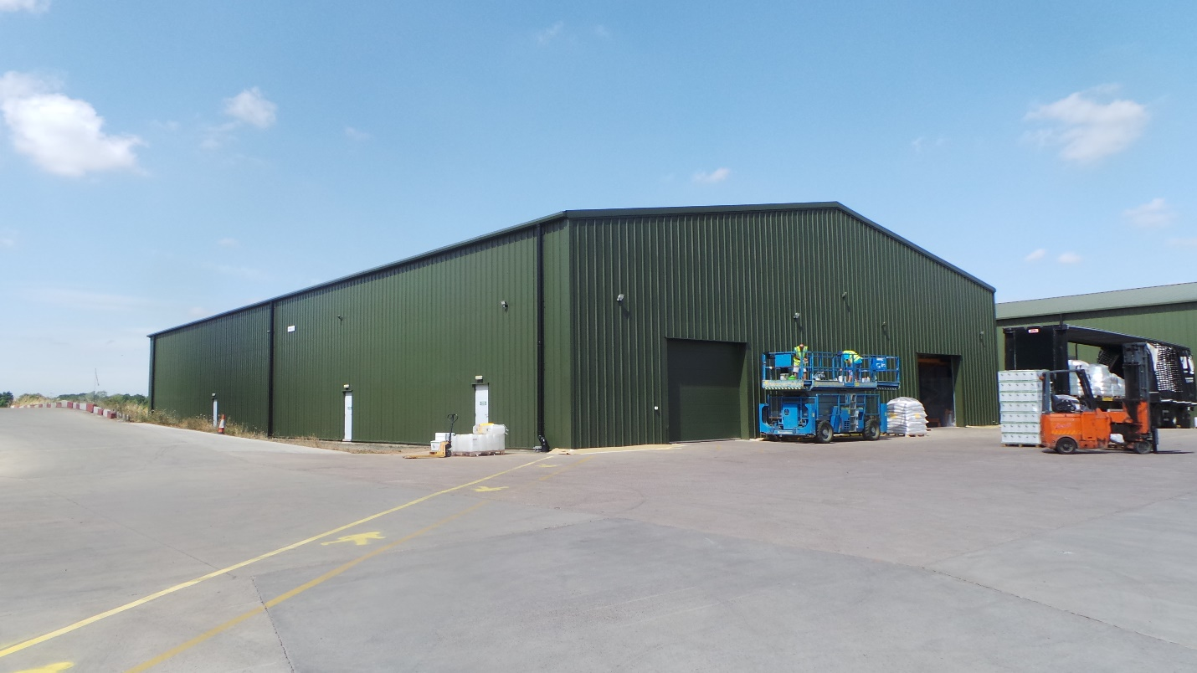

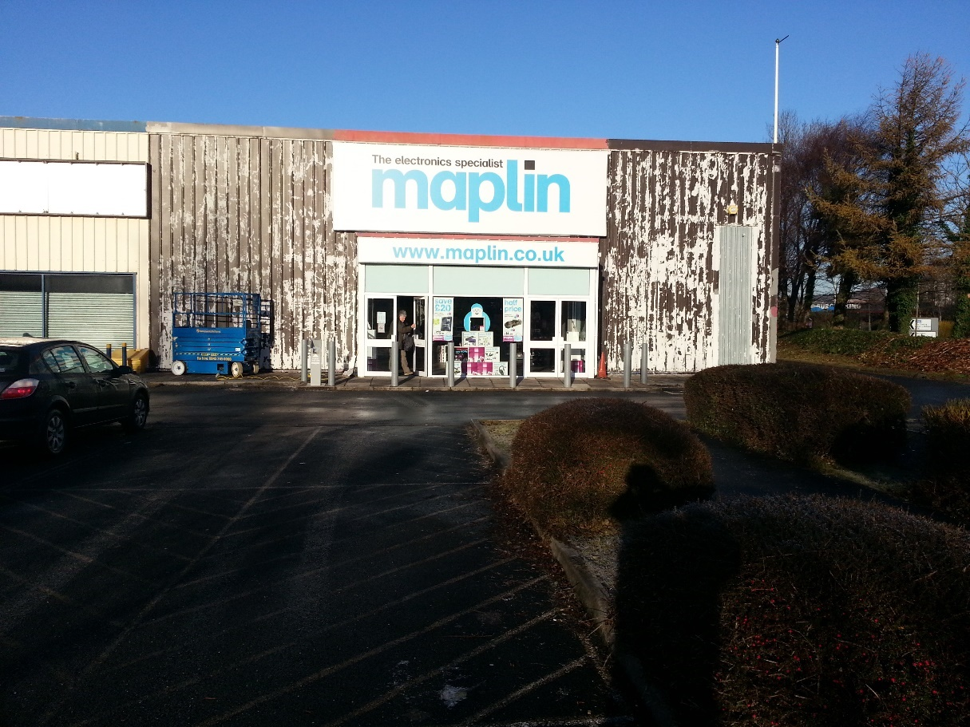

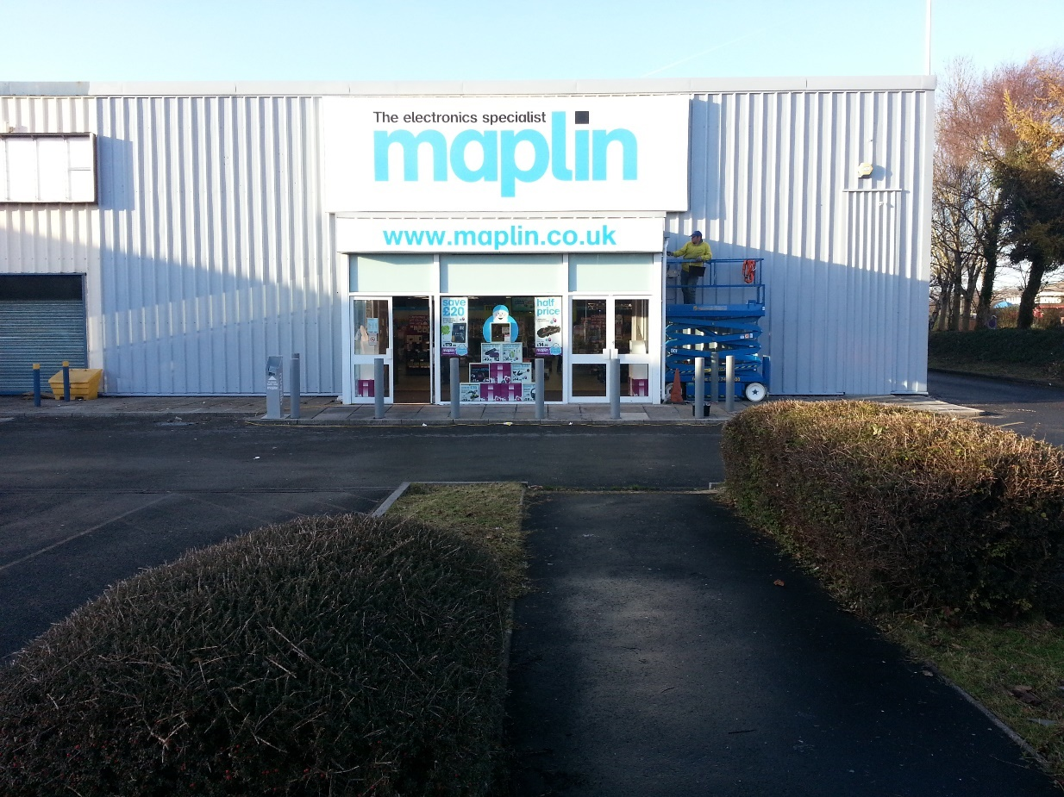

[Roof Coating Systems](https://www.elevationmaintenance.co.uk/services/on-site-spraying-services/liquid-roof)

Coatings and Blasting Services offers a specialist service to reseal and clean roof cladding using liquid roof coatings which cure to form a rubber-like elastomeric waterproof membrane.

Aged Roofing SheetsWhen factory applied coatings reach the end of their lifespan and no longer offer protection to the exposed steel sheet it is imperative that the protective coating is replaced before any issues occur or the sheet has the chance to delaminate further.

Asbestos sheeting was originally used for the roofs of many buildings across the UK as it was a lightweight alternative to slate and tile roofing. The fibres of asbestos provide enough strength and flexibility to allow sheets to be pressed into standard profiles that can perform to a 50 year life expectancy. However, this alternative was only used until the 1980s when the dangers of asbestos were identified.

There are still many commercial buildings which use asbestos cement roofs which can create potentially huge problems. Disturbing these sheets for repair requires specialist contractors of which Coatings and Blasting Services are. The sheets can be prone to cracking and corrode, lifting them from their original positions causing leaks.

Our Treatment  
The most cost effective and safest way to deal with this issue is to encapsulate the surface of the sheet with sealed coating. Coatings and Blasting Services uses Girosil Roofcoat®, an ideal solution to provide a flexible, waterproof and breathable membrane.

The benefits include:  
•The original sheet remains undisturbed which reduces costs, disruption and safety controls.  
• Fully moisture tolerant

* completely resistant to sunlight and UV radiation, ensuring enduring flexibility and adhesion.  
  • Durability – life expectancy of over 20 years

Loose Fixings  
An added problem that may be encountered is loose fixings, which often cause leaks and corroded threads means that they cannot be tightened. A simple solution to this problem is to seal the fixing with Girosil Edge. It is unaffected by UV light or extreme weather and provides a fast yet effective way to seal any small problems.

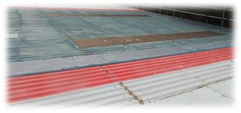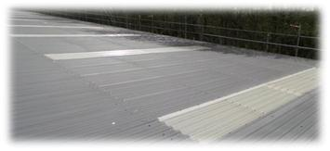

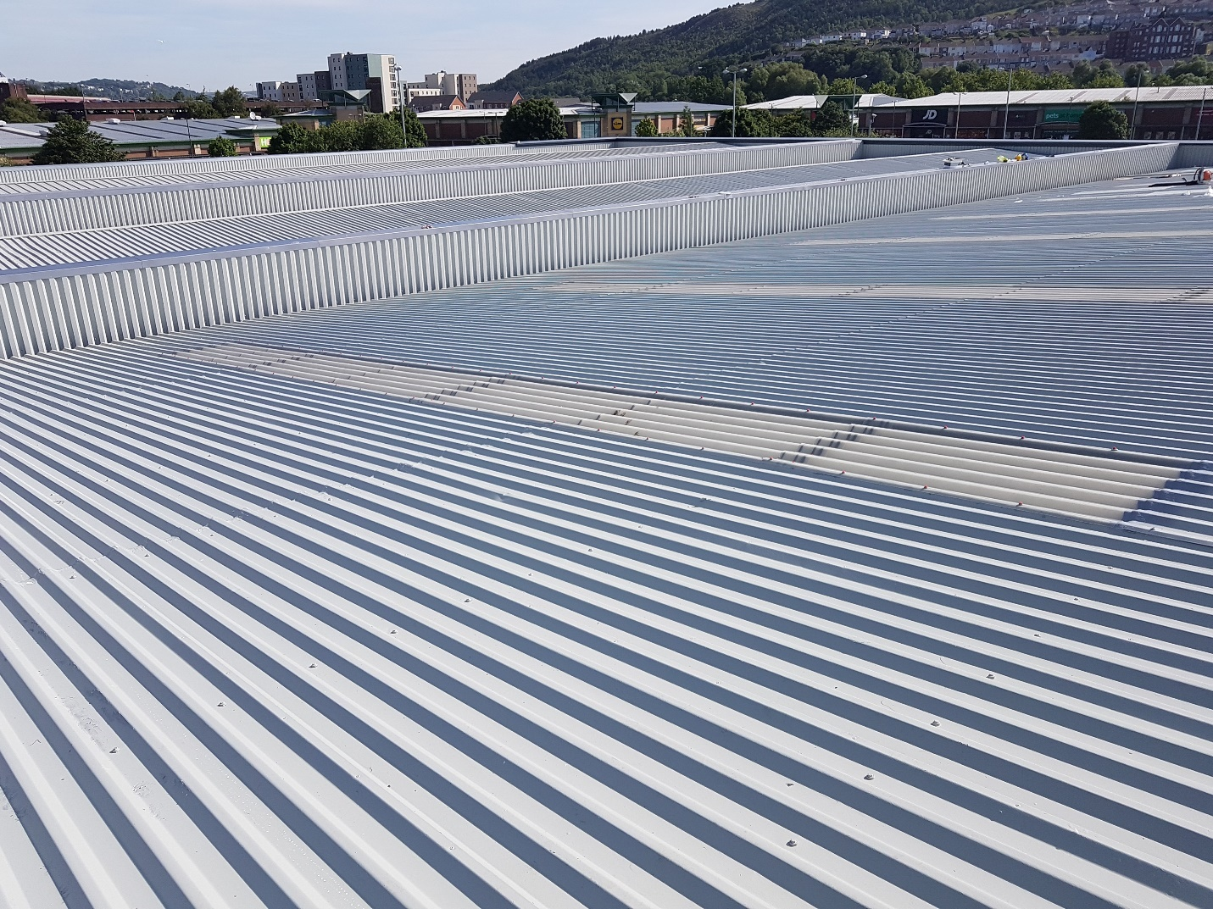

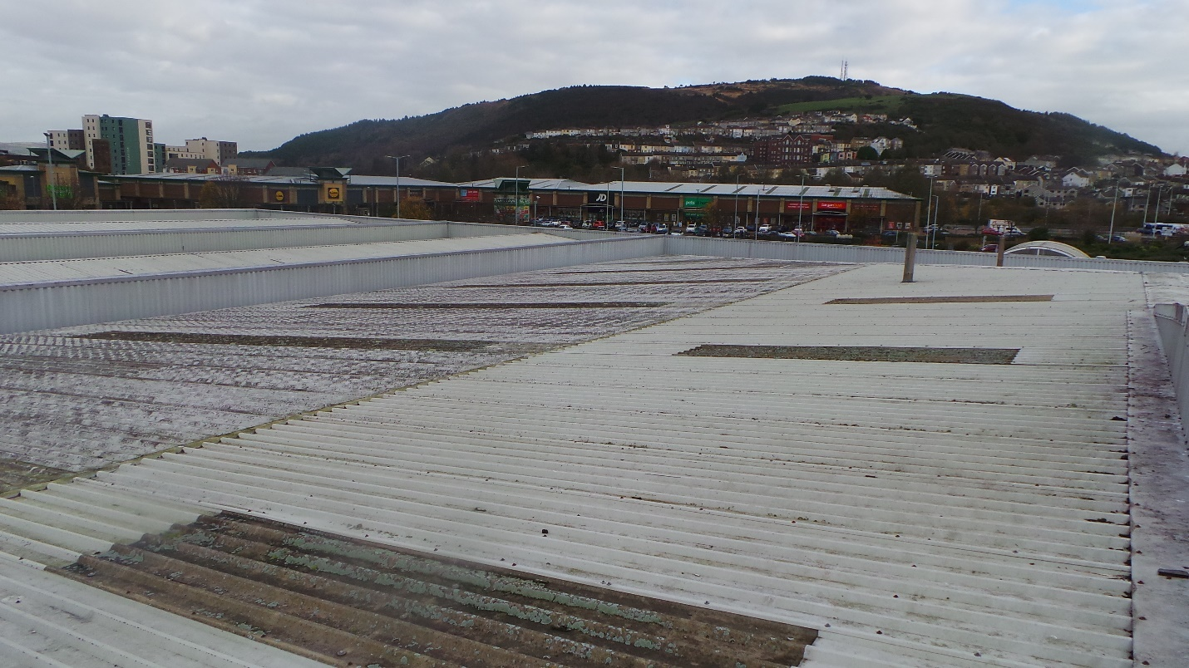

Cut Edge Corrosion  
Corrosion is most commonly seen at the roof sheet overlaps, gutter/eaves and on ridge flashings where factory protective coatings gradually start to peel away as a result of the steel sheets being cut on installation and left exposed to the elements.

As the existing coatings fail the steel is exposed and left vulnerable to rust and corrosion. If this problem is neglected it will progressively become worse and move away from just the edges to the weather-sealed lap joints and gutter overhang. Creating weaknesses within the buildings structure. However, if the problem is dealt with from the beginning the it will prevent costly sheet replacement, maintenance and repairs.

Our Treatment  
Coatings and blasting Services Ltd is an approved Giromax applicator for Girosil Edge, a product developed specifically for the treatment of cut edge corrosion. It provides many benefits which include:

• A strong and flexible external joint  
• Applied without disturbing any existing sheets and fixings.  
• It is unaffected by UV light or weather extremes.  
• Cost effective and reliable way to prevent further corrosion

* Fully moisture tolerant

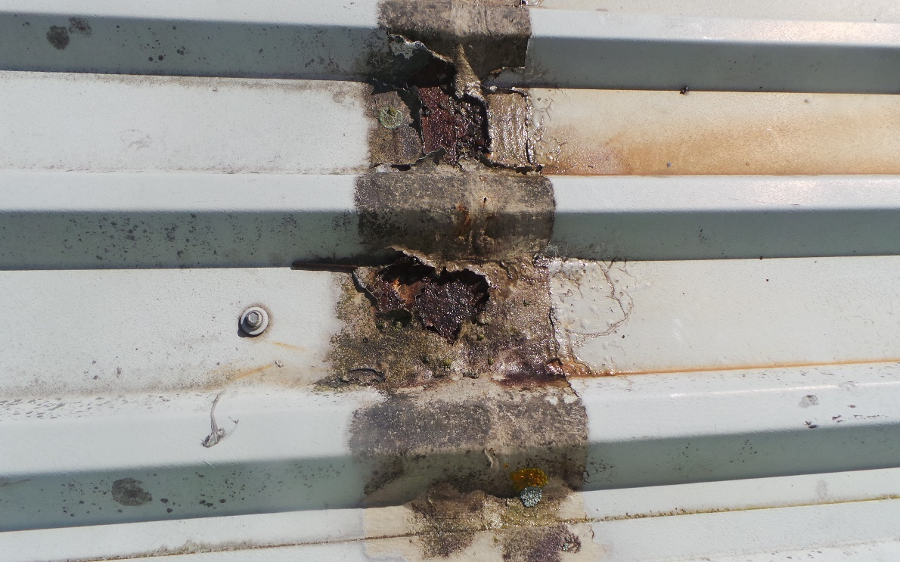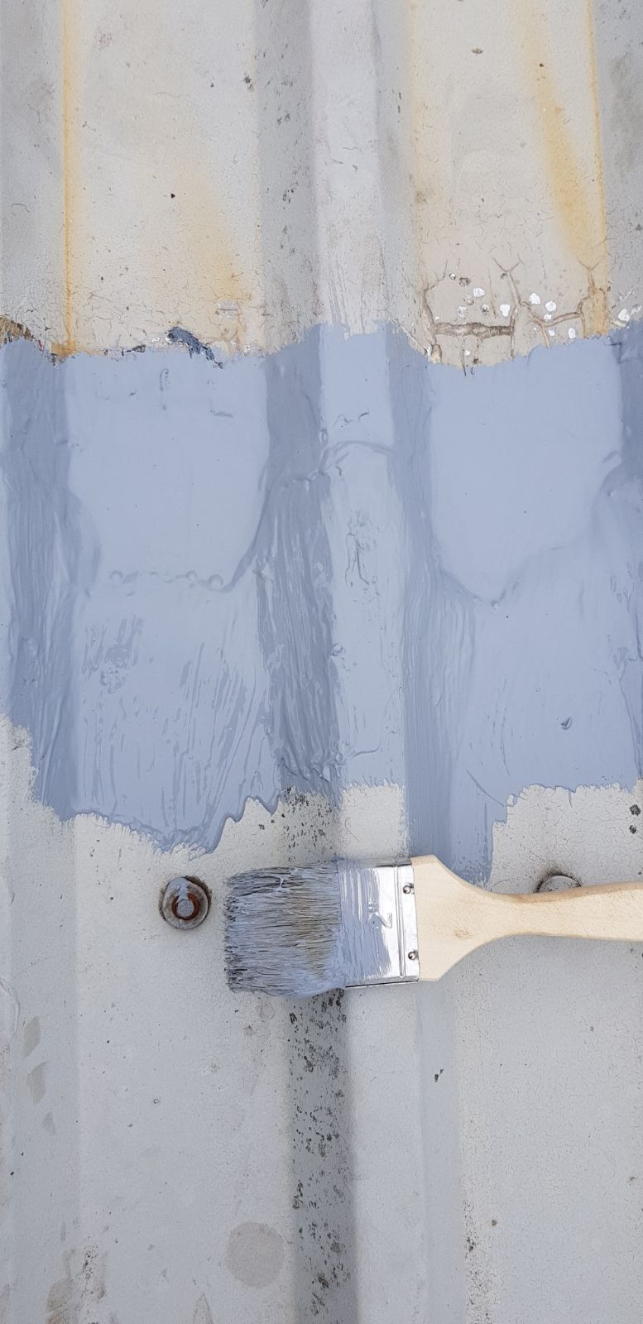

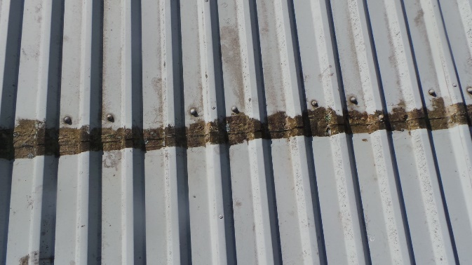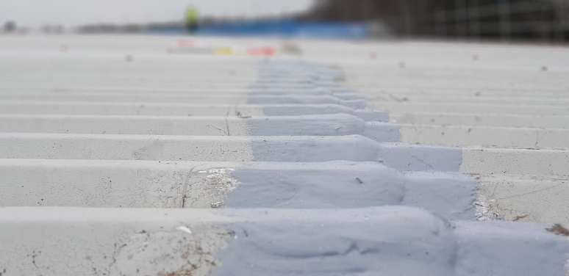

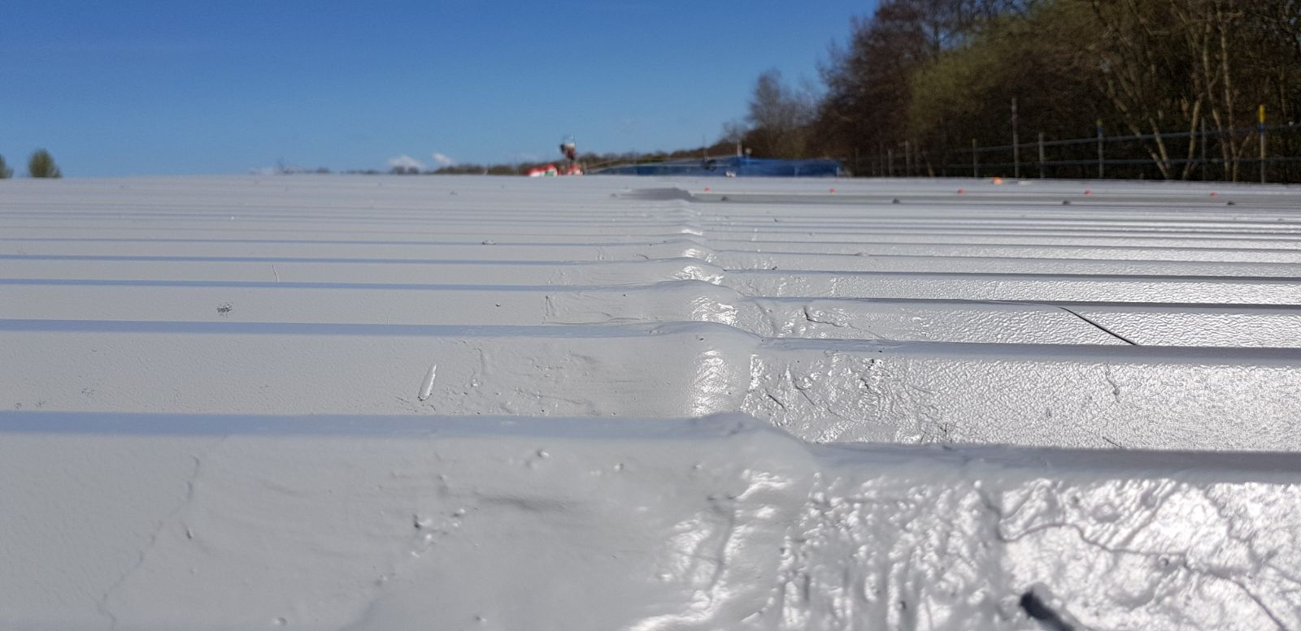

Gutter relining

Unlike cladding sheets which follow a known pattern of deterioration over their life cycle, gutter condition and performance is dependent on many different factors such as drainage, silt and vegetation growth and previously applied coatings.

Our Treatment  
Coatings and blasting Services Ltd is an approved Giromax applicator for Girosil Gutter, a product developed specifically for refurbishment of gutter systems. It provides many benefits which include:

• High water repellence

* protection against future cracks, splits and leaks

• drying to form a seamless layer without joints or seams  
• It is unaffected by UV light or weather extremes.  
• Cost effective and reliable way to prevent further corrosion



  
  
  